[[1]](#footnote-1)

Preparation of Papers for IEEE JOURNALS(adapted for the Workshop on Microsystems)

First A. Author, Second B. Author, and Third C. Author

Add affiliations here

*Abstract*—These instructions give you guidelines for preparing papers for IEEE Transactions and Journals*.* They have been lightly adapted to fit the requirements of the Workshop on Microsystems. The suggested extended abstract size is 2 pages in IEEE-style double-column format. Use this document as a template if you are using Microsoft *Word* 6.0 or later. Otherwise, use this document as an instruction set. The electronic file of your paper will be formatted further at IEEE. Paper titles should be written in uppercase and lowercase letters, not all uppercase. Avoid writing long formulas with subscripts in the title; short formulas that identify the elements are fine (e.g., "Nd–Fe–B"). Do not write “(Invited)” in the title. Full names of authors are preferred in the author field, but are not required. Put a space between authors’ initials. Define all symbols used in the abstract. Do not cite references in the abstract. Do not delete the blank line immediately above the abstract; it sets the footnote at the bottom of this column.

*Index Terms*—Enter key words or phrases in alphabetical order, separated by commas. For a list of suggested keywords, send a blank e-mail to [keywords@ieee.org](mailto:keywords@ieee.org) or visit <http://www.ieee.org/organizations/pubs/ani_prod/keywrd98.txt>

# INTRODUCTION

T

HIS document is a template for Microsoft *Word* versions 6.0 or later. If you are reading a paper or PDF version of this document, please download the electronic file,  
TRANS-JOUR.DOC, from the IEEE Web site at <http://www.ieee.org/web/publications/authors/transjnl/index.html> so you can use it to prepare your manuscript style and sample files from the same Web page. Use these LATEX files for formatting, but please follow the instructions in TRANS-JOUR.DOC or TRANS-JOUR.PDF.

If your paper is intended for a conference*,* please contact your conference editor concerning acceptable word processor formats for your particular conference.

# Guidelines For Manuscript Preparation

When you open TRANS-JOUR.DOC, select “Page Layout” from the “View” menu in the menu bar (View | Page Layout), (these instructions assume MS 6.0. Some versions may have alternate ways to access the same functionalities noted here). Then, type over sections of TRANS-JOUR.DOC or cut and paste from another document and use markup styles. The pull-down style menu is at the left of the Formatting Toolbar at the top of your *Word* window (for example, the style at this point in the document is “Text”). Highlight a section that you want to designate with a certain style, then select the appropriate name on the style menu. The style will adjust your fonts and line spacing. Do not change the font sizes or line spacing to squeeze more text into a limited number of pages.Use italics for emphasis; do not underline.

## Abbreviations and Acronyms

Define abbreviations and acronyms the first time they are used in the text, even after they have already been defined in the abstract. Abbreviations such as IEEE, SI, ac, and dc do not have to be defined. Abbreviations that incorporate periods should not have spaces: write “C.N.R.S.,” not “C. N. R. S.” Do not use abbreviations in the title unless they are unavoidable (for example, “IEEE” in the title of this article).

## Other Recommendations

Use one space after periods and colons. Hyphenate complex modifiers: “zero-field-cooled magnetization.” Avoid dangling participles, such as, “Using (1), the potential was calculated.” [It is not clear who or what used (1).] Write instead, “The potential was calculated by using (1),” or “Using (1), we calculated the potential.”

Cite Figures and tables in the text before their appearance. Preferably, place Figures and tables on the top or on the bottom of a column (e.g. Fig.1).

C:\Users\mk\Desktop\16_PowerMEMS_copyof_EHchapter_DynamicSchematic.wmf

Fig. 1. Schematic description of the system concept. It is good practice to explain the significance of the figure in the caption.

Use a zero before decimal points: “0.25,” not “.25.” Use “cm3,” not “cc.” Indicate sample dimensions as “0.1 cm × 0.2 cm,” not “0.1 × 0.2 cm2.” The abbreviation for “seconds” is “s,” not “sec.” Use “Wb/m2” or “webers per square meter,” not “webers/m2.” When expressing a range of values, write “7 to 9” or “7-9,” not “7~9.”

Punctuate equations when they are part of a sentence, as in

 (1)

TABLE I

Units for Magnetic Properties

|  |  |  |
| --- | --- | --- |
| Symbol | Quantity | Conversion from Gaussian and  CGS EMU to SI a |
| Φ | magnetic flux | 1 Mx → 10−8 Wb = 10−8 V·s |
| *B* | magnetic flux density,  magnetic induction | 1 G → 10−4 T = 10−4 Wb/m2 |
| *H* | magnetic field strength | 1 Oe → 103/(4π) A/m |
| *m* | magnetic moment | 1 erg/G = 1 emu  → 10−3 A·m2 = 10−3 J/T |
| χρ | mass susceptibility | 1 cm3/g → 4π × 10−3 m3/kg |
| μ | permeability | 1 → 4π × 10−7 H/m  = 4π × 10−7 Wb/(A·m) |
| μr | relative permeability | μ → μr |
| *w, W* | energy density | 1 erg/cm3 → 10−1 J/m3 |
| *N, D* | demagnetizing factor | 1 → 1/(4π) |

Vertical lines are optional in tables. Statements that serve as captions for the entire table do not need footnote letters.

aGaussian units are the same as cg emu for magnetostatics; Mx = maxwell, G = gauss, Oe = oersted; Wb = weber, V = volt, s = second, T = tesla, m = meter, A = ampere, J = joule, kg = kilogram, H = henry.

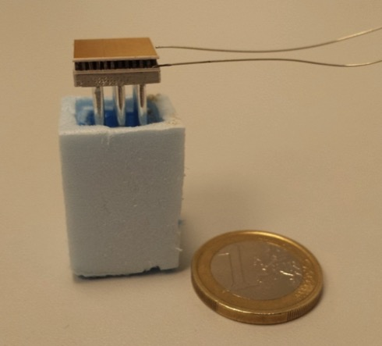

Fig. 2. Image of the fabricated device showing the size scale [12]

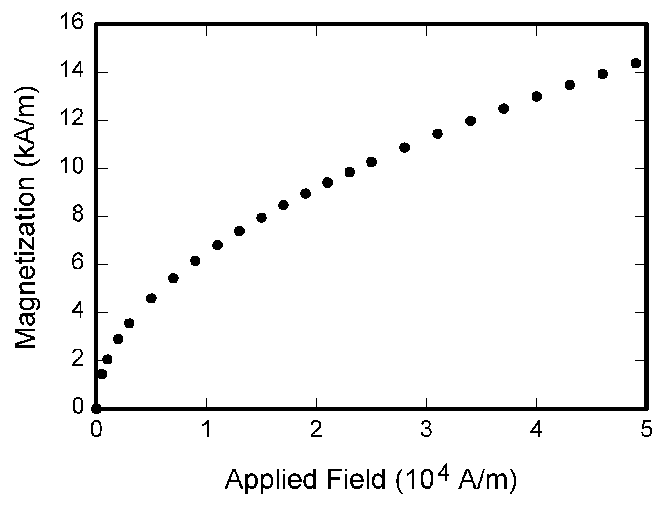

Fig. 3. Show quantitative calculated and experimental data, using S.I. units and minimize digits on the axes scales where possible.

# Copyright

Please note explicitly that all content has been created by the authors in your submission e-mail.

References

1. G. O. Young, “Synthetic structure of industrial plastics,” in *Plastics,* 2nd ed., vol. 3, J. Peters, Ed. New York: McGraw-Hill, 1964, pp. 15–64.
2. W.-K. Chen, *Linear Networks and Systems.* Belmont, CA: Wadsworth, 1993, pp. 123–135.
3. J. U. Duncombe, “Infrared navigation—Part I: An assessment   
   of feasibility,” *IEEE Trans. Electron Devices*, vol. ED-11, no. 1, pp. 34–39, Jan. 1959.
4. E. P. Wigner, “Theory of traveling-wave optical laser,” *Phys. Rev*.,   
   vol. 134, pp. A635–A646, Dec. 1965.
5. E. H. Miller, “A note on reflector arrays,” *IEEE Trans. Antennas Propagat*., to be published.
6. E. E. Reber, R. L. Michell, and C. J. Carter, “Oxygen absorption in the earth’s atmosphere,” Aerospace Corp., Los Angeles, CA, Tech. Rep. TR-0200 (4230-46)-3, Nov. 1988.
7. J. H. Davis and J. R. Cogdell, “Calibration program for the 16-foot antenna,” Elect. Eng. Res. Lab., Univ. Texas, Austin, Tech. Memo. NGL-006-69-3, Nov. 15, 1987.
8. *Transmission Systems for Communications*, 3rd ed., Western Electric Co., Winston-Salem, NC, 1985, pp. 44–60.
9. *Motorola Semiconductor Data Manual*, Motorola Semiconductor Products Inc., Phoenix, AZ, 1989.
10. J. Jones. (1991, May 10). *Networks.* (2nd ed.) [Online]. Available: [http://www.atm.com](http://www.atm.com/)
11. R. J. Vidmar. (1992, Aug.). On the use of atmospheric plasmas as electromagnetic reflectors. *IEEE Trans. Plasma Sci.* [Online]. *21(3),* pp. 876–880. Available:<http://www.halcyon.com/pub/journals/21ps03-vidmar>
12. M. E. Kiziroglou, A. Elefsiniotis, N. Kokorakis, S. W. Wright, T. T. Toh, P. D. Mitcheson, U. Schmid, Th. Becker and E. M. Yeatman, Scaling and super-cooling in heat storage harvesting devices, Microsystem Technologies, 22, 1905, 2016

1. [↑](#footnote-ref-1)